What is Angular ?

* Angular is a **JavaScript Framework** which allows you to create reactive **Singe-Page-Applications** (SPAs).
* A tool to help you build interactive websites - Framework
* Angular is a platform and framework for building single-page client applications using HTML and TypeScript. Angular is written in TypeScript. It implements core and optional functionality as a set of TypeScript libraries that you import into your apps. - angular.io

Angular Features:

Benefits of using Angular:

* Increases code reusability
* Provides structure to JavaScript
* Makes an application more testable
* Gives our application a clean structure
* Modular development
* Two-way data-binding
* Great for SPA (Single-Page Applications)
* Supported by Google
* Provides a great selection of third-party integrations that can be added to the framework
* Angular offers faster load time and increased security by using AOT ( ahead-of-time compiler)
* Open source
* Documentation
* Performance

Framework:

* Router, http, forms, rxjs, etc..

Other Frameworks:

1. Angular
2. React
3. Viu.js
4. Blazor (.NET)

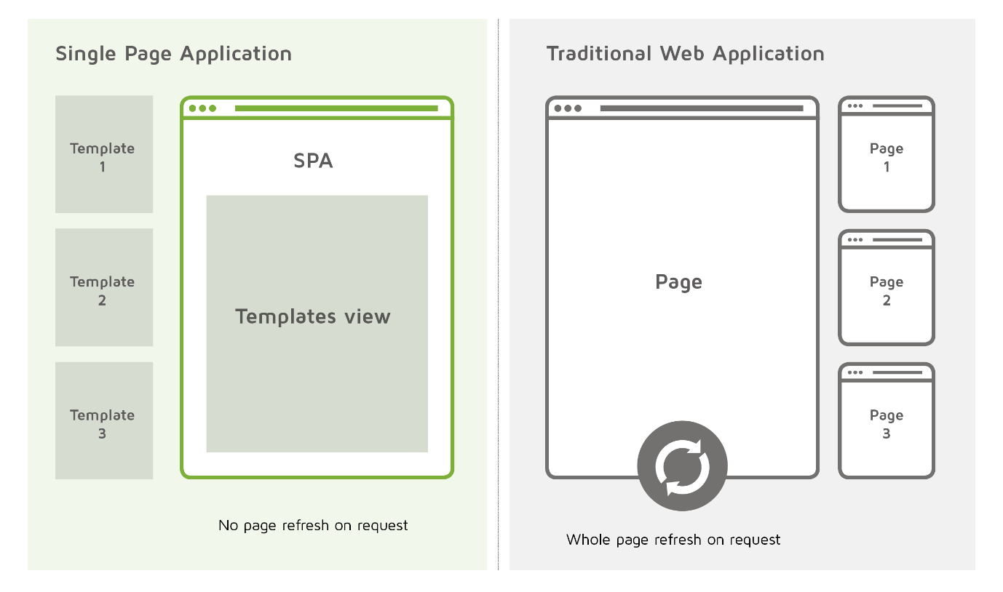

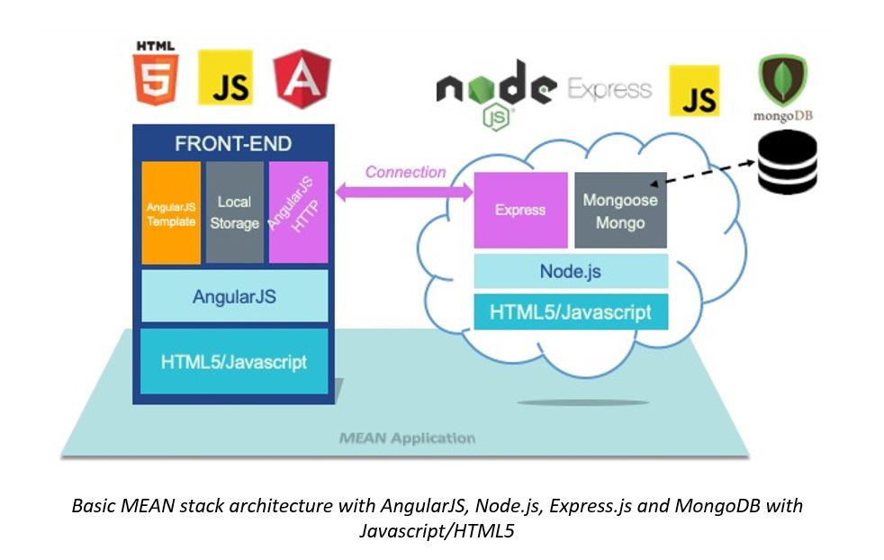

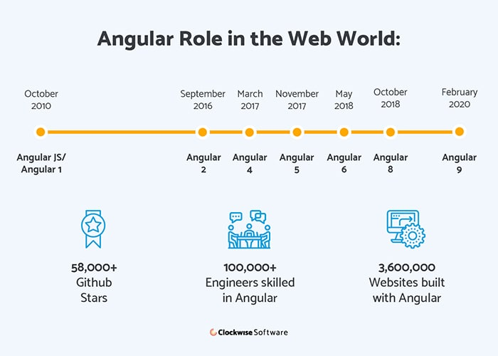

Top 8 Angular and AngularJs Apps to inspire you:

1. Gmail
2. Forbes
3. Upwork
4. PayPal
5. Weather.com
6. Wikiwand
7. JetBlue

Source: <https://clockwise.software/blog/best-angular-applications/>

Architecture:

1. Modules
2. Components
3. Templates, directives and data binding
4. Service and dependency injection
5. Routing

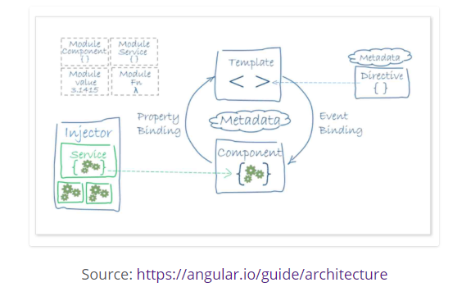

Source:

<https://www.digitalclaritygroup.com/wp-content/uploads/2017/10/SPA-1.png>

<https://www.castsoftware.com/images/blog-images/basic-mean-stack.jpg>

<https://www.stepbystepschools.net/wp-content/uploads/2016/11/DOM.png>